DOKTORAND:
GRAD: | Philosophiae doctor
FAKULTET: | Det medisinske fakultet
INSTITUTT:
FAGOMRÅDE:
VEILEDERE:
DISPUTASDATO:
AVHANDLINGENS TITTEL: | Tittelen i kursiv
Please insert a brief POPULAR SCIENCE SUMMARY (IN NORWEGIAN) here:

DOCTORAL CANDIDATE:
DEGREE: | Philosophiae doctor
FACULTY: | Faculty of Medicine
DEPARTMENT:
AREA OF EXPERTICE:
SUPERVISORS:
DATE OF DISPUTATION:
DISSERTATION TITLE: | Title in cursive
Please insert A BRIEF PROFESSIONAL SUMMARY of the thesis in English:

Short description of your doctoral work
The conferment ceremony in the University Aula is a formal and beautiful event. You will be called up on stage where the Dean of the Faculty of Medicine will introduce you and your doctoral work, and the rector will present you with your ceremonial diploma.
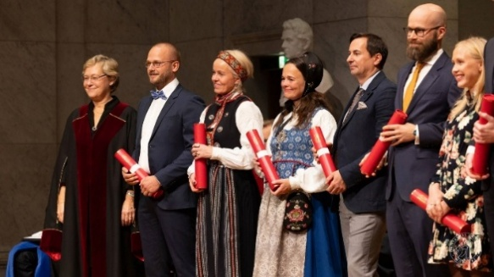
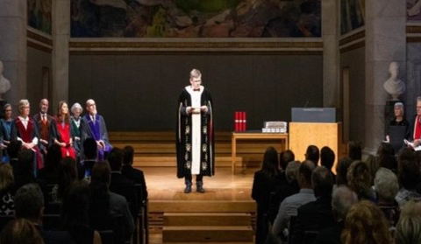

In connection with this ceremony, we therefore need a very brief description of your doctoral work. The text should be understandable to all guests attending the ceremony.
The description should:
- begin with your full name as registered in Studentweb
- be able to be read aloud within 15 seconds
- describe your doctoral work in a maximum of two sentences
- include theme and findings
- not contain complicated technical language
- be in Norwegian
We take the liberty of simplifying and shortening your description for reasons of time and space. If we make changes to the academic content of the text, we will ask you to confirm that it still accurately reflects your work.

Examples of good conferment texts:
NN har ved studier i cellekulturer og dyremodeller funnet dokumentasjon for to hittil ukjente arvelige sykdommer som skyldes defekter i cilier, hårliknende strukturer som finnes i nesten alle celler hos mennesker.
NN har undersøkt sen-effekter hos personer som er strålebehandlet for øre-nese-hals-kreft. Hun fant høy forekomst av munntørrhet, svelgvansker og fatigue mer enn fem år etter avsluttet behandling.

Description of your doctoral work:
Please insert text here

