Introducing precision medicine for cancer patients on a national scale
Ahus and the other university hospitals are collaborating on a national boost to offer cancer patients equal access to advanced personalized diagnostics where traditional treatment does not give results. The collaboration is now being presented internationally.
Published 06/05/2022
Last updated 09/05/2022

Illustrasjonsfoto: Colourbox

For cancer patients who no longer have the effect of standard cancer treatment, precision medicine can be an option. Through extended genetic testing, one can see whether gene changes or other molecular characteristics of the cancer cells indicate that specific drugs can be used to attack the tumor's weak point to provide targeted treatment. Extended genetic testing implies analyzing gene changes (mutations) in the tumor for over 500 cancer-related genes.​
In the past, such broad genetic testing of tumor tissue has not been publicly available. Extended diagnostics challenges the traditional organization of the health service in that new types of skills are required. In order to contribute to a national joint effort for the implementation of extended molecular diagnostics, a national network, InPreD, was formed, where all six university hospitals collaborate to provide access to advanced molecular diagnostics. Thus making it possible for patients throughout the country, to receive offer for precision medicine in cancer.
An article about the collaboration has recently been published in the renowned journal Nature Medicine, with several co-authors from Ahus. The authors believe that the experiences from the project can serve as a model for other countries that want to do the same.
https://www.nature.com/articles/s41591-022-01777-4

Innovation​
The collaboration includes a large national clinical study, IMPRESS, in which all 17 hospitals offering cancer treatment participate. In the study, trial treatment is offered to patients who have undergone a full course of treatment and do not have a clear way forward.

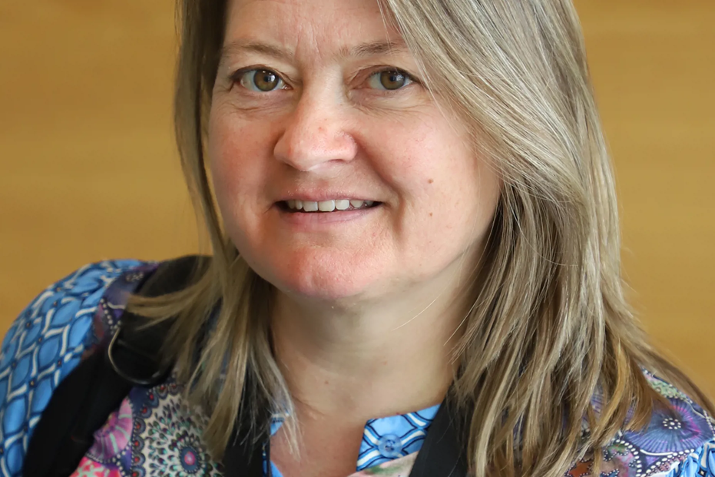
Professor Hilde Loge Nilsen, (previous) head of the unit for precision medicine at Ahus.

Broad genetic testing of tumor tissue has not been publicly available until now. The IMPRESS study represents an innovation considering that this can become an offer to all cancer patients, says Hilde Loge Nilsen, previous head of the unit for precision medicine at Ahus.
Until now, Ahus has been one of two hospitals that collaborate on broad genetic testing of patients from all over the country.
- In addition to gene testing Ahus patients, Ahus contributes to the screening of patients from other hospitals, such as Vestre Viken and Kristiansand hospitals.
If a gene change or another characteristic that are identified indicating that the patient can benefit from one of the drugs in the study, the patient will be able to be included in the IMPRESS study.
- We often find gene changes that open the way for participation in other clinical studies outside of IMPRESS.
Strict requirements for inclusion
Precision medicine will be able to provide significant benefits for some patients, and the proportion of patients who benefit directly is expected to increase dramatically as the capacity for extended molecular diagnostics and the knowledge increases. But, Nilsen emphasizes, that it is still not all patients for whom this will be relevant:
- There are strict requirements to be included. The patient's general condition must be good and have a certain life expectancy, because the gene sequencing process can take up to four weeks. In addition, it is not certain that we will actually find a gene variant that can be treated. Of those assessed for inclusion, we found new treatment options for 23 per cent.
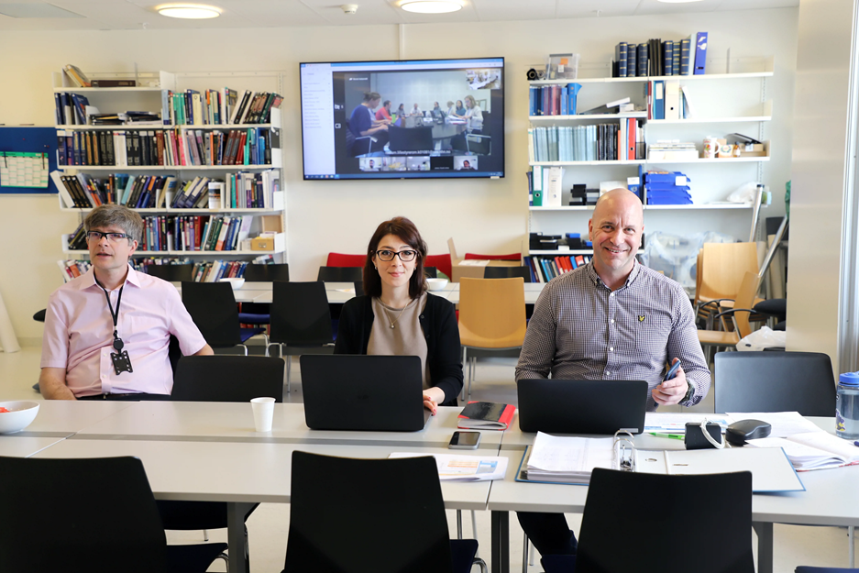
Experts from all over the country meet to assess which patients can benefit from new treatment options.
In the beginning of the study, eight medicines were being tested. Today, the study includes 23 medicines, and with an ever-increasing knowledge, more and more patients can be offered personalized treatment. So far, 72 included patients have had extended molecular testing at Ahus: 13 Ahus patients, 5 from Bærum, 21 from Drammen, 32 from Kristiansand and 1 from St. Olav's hospital. Nationally, 359 patients have been screened as of 25.04.22.

Precision medicine at Ahus
The IMPRESS study is led by Oslo University Hospital, which opened for inclusion before the summer of 2021. At Ahus, the study is part of a larger investment in precision medicine, including a separate unit for precision medicine, which has been managed by Hilde Loge Nilsen until 31.12.2023 and Diana Lilian Bordin from January 2024.
The oncology department at Ahus was central in the first treatment study that provides the basis for the implementation of precision medicine in Norway – the MetAction study, led by Anne Hansen Ree.
- At Ahus, we are therefore in the fortunate situation that we can benefit from practical and theoretical expertise within precision medicine in experimental treatment, says Hilde Loge Nilsen.
At Ahus, Anne Hansen Ree, Hilde Loge Nilsen, Ulla Randen and Dag Kristen Solberg participate in a regional competence network for precision medicine. Ulla Randen and Hilde Loge Nilsen also participate in the national network InPred Norway. At Ahus, a professional council and an infrastructure for precision diagnostics (InPreD-Ahus) have also been established which are harmonized with the national infrastructure for precision diagnostics.
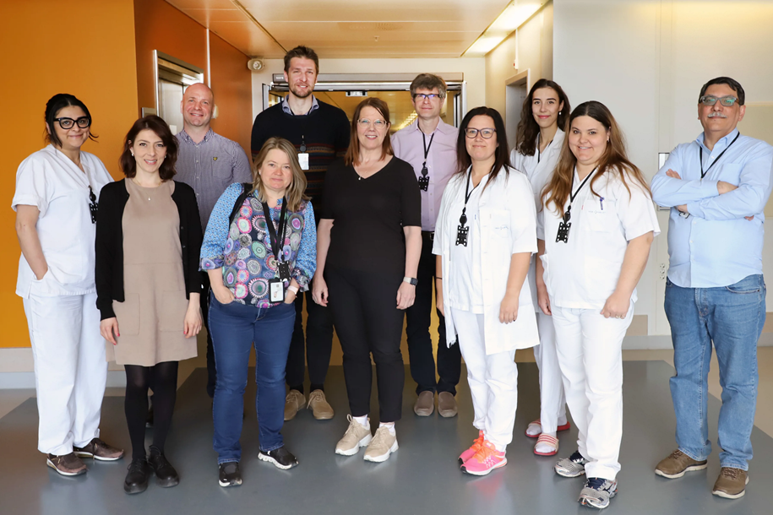
Participants in InPreD-Ahus, and representatives from the department of pathology at Ahus.
First row from left: Nazanin Rouhee, Department of Pathology; Diana Bordin, variant interpretation Precision Medicine Group, InPreD; Professor Hilde Nilsen, InPreD; Ulla Randen, head of Department of Pathology; Gro Gundersen, Department of Pathology; Annette Alta, Department of Pathology; Vahid Bemanian, Department of Pathology.
Second row from left: Chris Noone, Precision Medicine Group coordinator, InPreD; oncologist Sebastian Meltzer, InPreD; Lorant Farkas, InPreD; Kristine Ladegård, Department of Pathology.​

